Chapter 2
LITERATURE REVIEW

2. LITERATURE REVIEW

2.1 Motivation
The collection of digital information by governments, corporations, and individuals has created tremendous opportunities for knowledge-based decision making. Driven by mutual benefits, or by regulations that require certain data to be published, there is a demand for the exchange and publication of data among various parties. For example, licensed hospitals in California are required to submit specific demographic data on every patient discharged from their facility. In June 2004, the Information Technology Advisory Committee released a report entitled Revolutionizing Health Care Through Information Technology. One of its key points was to establish a nationwide system of electronic medical records that encourages sharing of medical knowledge through computer-assisted clinical decision support. Data publishing is equally ubiquitous in other domains. For example, Netflix, a popular online movie rental service, recently published a data set containing movie ratings of 500,000 subscribers, in a drive to improve the accuracy of movie recommendations based on personal preferences; AOL published a release of query logs but quickly removed it due to the reidentification of a searcher.

Detailed person-specific data in its original form often contains sensitive information about individuals, and publishing such data immediately violates individual privacy. The current practice primarily relies on policies and guidelines to restrict the types of publishable data and on agreements on the use and storage of sensitive data. The limitation of this approach is that it either distorts data excessively or requires a trust level that is impractically high in many data-sharing scenarios. For example, contracts and agreements cannot guarantee that sensitive data will not be carelessly misplaced and end up in the wrong hands.

A task of the utmost importance is to develop methods and tools for publishing data in a more hostile environment, so that the published data remains practically useful while individual privacy is preserved. This undertaking is called privacy-preserving data publishing (PPDP). In the past few years, research communities have responded to this challenge and proposed many approaches. While the research field is still rapidly developing, it is a good time to discuss the assumptions and desirable properties for PPDP, clarify the differences and requirements that distinguish PPDP from other related problems, and systematically summarize and evaluate different approaches to PPDP.

2.2 Models of Data Publishing
There are two models of data publishers.

In the untrusted model, the data publisher is not trusted and may attempt to identify sensitive information from record owners. Various cryptographic solutions; anonymous communications and statistical methods were proposed to collect records anonymously from their owners without revealing the owner’s identity.

In the trusted model, the data publisher is trustworthy and record owners are willing to provide their personal information to the data publisher; however, the trust is not transitive to the data recipient. In this survey, we assume the trusted model of data publishers and consider privacy issues in the data publishing phase.

2.3 The Anonymization Approach
In the most basic form of PPDP, the data publisher has a table of the form
D(Explicit Identifier, Quasi Identifier, Sensitive Attributes, Non-Sensitive Attributes), where Explicit Identifier is a set of attributes, such as name and social security number (SSN), containing information that explicitly identifies record owners; Quasi Identifier (QID) is a set of attributes that could potentially identify record owners; Sensitive Attributes consists of sensitive person-specific information such as disease, salary, and disability status; and Non-Sensitive Attributes contains all attributes that do not fall into the previous three categories . The four sets of attributes are disjoint. Most works assume that each record in the table represents a distinct record owner.

Anonymization refers to the PPDP approach that seeks to hide the identity and/or the sensitive data of record owners, assuming that sensitive data must be retained for data analysis. Clearly, explicit identifiers of record owners must be removed. Even with all explicit identifiers being removed, Sweeney showed a real-life privacy threat to William Weld, former governor of the state of Massachusetts. In Sweeney’s example shown in Figure 2.3, an individual’s name in a public voter list was linked with his record in a published medical database through the combination of zip code, date of birth, and sex, as shown in Figure 2.3. Each of these attributes does not uniquely identify a record owner, but their combination, called the quasi identifier, often singles out a unique or a small number of record owners. According to Sweeney, 87% of the U.S. population had reported characteristics that likely made them unique based on only such quasi-identifiers.

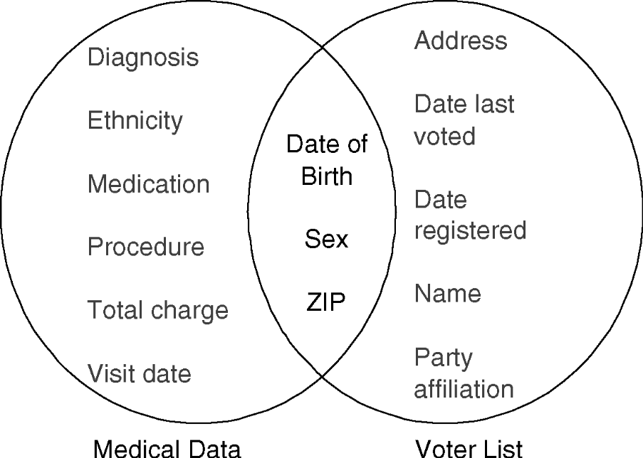
Figure 2.3 Record Linkage [Sweeny’s example]

In the above sweeny’s example, the owner of a record is reidentified by linking his quasi identifier. To perform such linking attacks, the attacker needs two pieces of prior knowledge: the victim’s record in the released data and the quasi-identifier of the victim. Such knowledge can be obtained by observation. For example, the attacker noticed that his boss was hospitalized, and therefore knew that his boss’s medical record would appear in the released patient database. Also, it was not difficult for the attacker to obtain his boss’s zip code, date of birth, and sex, which could serve as the quasi-identifier in linking attacks. To prevent linking attacks, the data publisher provides an anonymous table, T(QID, Sensitive Attributes, Non-Sensitive Attributes), QID is an anonymous version of the original QID obtained by applying anonymization operations to the attributes in QID in the original table D. Anonymization operations hide some detailed information so that several records become indistinguishable with respect to QID. Consequently, if a person is linked to a record through QID, that person is also linked to all other records that have the same value for QID, making the linking ambiguous. Alternatively, anonymization operations could generate synthetic data table T based on the statistical properties of the original table D, or add noise to the original table D. The anonymization problem is to produce an anonymous T that satisfies a given privacy requirement determined by the chosen privacy model and to retain as much data utility as possible. An information metric is used to measure the utility of an anonymous table. Note that the Non-Sensitive Attributes are published if they are important to the data mining task.

2.4 Privacy Models
We can broadly classify privacy models into two categories based on their attack principles.

The first category considers that a privacy threat occurs when an attacker is able to link a record owner to a record in a published data table, to a sensitive attribute in a published data table, or to the published data table itself. We call these record linkage, attribute linkage, and table linkage, respectively. In all three types of linkages, we assume that the attacker knows the QID of the victim. In record and attribute linkages, we further assume that the attacker knows that the victim’s record is in the released table, and seeks to identify the victim’s record and/or sensitive information from the table. In table linkage, the attack seeks to determine the presence or absence of the victim’s record in the released table. A data table is considered to be privacy preserving if it can effectively prevent the attacker from successfully performing these linkages.

The second category aims at achieving the uninformative principle; The published table should provide the attacker with little additional information beyond the background knowledge. If the attacker has a large variation between the prior and posterior beliefs, we call it the probabilistic attack. Many privacy models in this family do not explicitly classify attributes in a data table into QID and Sensitive Attributes, but some of them could also thwart the sensitive linkages in the first category, so the two categories overlap.

2.5 Record Linkage
In the attack of record linkage, some value qid on Quasi Identifiers identifies a small number of records in the released table T, called a group. If the victim’s Quasi Identifier matches the value qid, the victim is vulnerable to being linked to the small number of records in the group. In this case, the attacker faces only a small number of possibilities for the victim’s record, and with the help of additional knowledge, there is a chance that the attacker could uniquely identify the victim’s record from the group. For example, Suppose that a hospital wants to publish the patient records in Table 2.5 (a) to a research center. Suppose that the research center has access to the external table 2.5(b) and knows that every person with a record in Table 2.5(b) has a record in Table 2.5(a). Joining the two tables on the common attributes Job, Sex, and Age may link the identity of a person to his/her Disease. For example, Doug, a male lawyer who is 38 years old, is identified as an HIV patient by qid = (Lawyer, Male, 38) after the join.
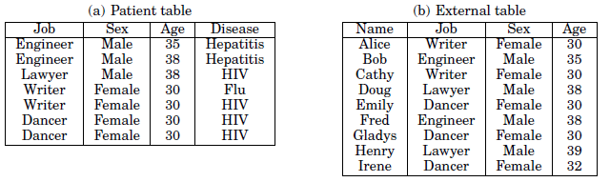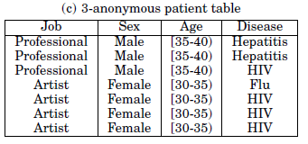
Table 2.5 Examples Illustrating Various Attacks
In k-Anonymity, To prevent record linkage through QID, Sweeney proposed the notion of k-anonymity: if one record in the table has some value qid, at least k− 1 other records also have the value qid. In other words, the minimum group size on QID is at least k. A table satisfying this requirement is called k-anonymous Table 2.5(c) is a 3-anonymous table. In a k-anonymous table, each record is indistinguishable from at least k-1 other records with respect to QID. Consequently, the probability of linking a victim to a specific record through QID is at most 1/k.

2.6 Attribute Linkage
In the attack of attribute linkage, the attacker may not precisely identify the record of the target victim, but could infer his/her sensitive values from the published data T, based on the set of sensitive values associated to the group that the victim belongs to. In case some sensitive values predominate in a group, a successful inference becomes relatively easy even if k-anonymity is satisfied. Clifton [2000] suggested eliminating attribute linkages by limiting the released data size. Limiting data size may not be desirable if data records such as HIV patient data, are valuable and are difficult to obtain. Several other approaches have been proposed to address this type of threat. The general idea is to diminish the correlation between QID attributes and sensitive attributes.

For example From Table 2.5(a), an attacker can infer that all female dancers at age 30 have HIV, i.e., (Dancer, Female, 30) → HIV with 100% confidence. Applying this knowledge to Table 2.1(b), the attacker can infer that Emily has HIV with 100% confidence provided that Emily comes from the same population in Table 2.5(a).

Machanavajjhala proposed the diversity principle, called l-diversity, to prevent attribute linkage. The l-diversity requires every qid group to contain at least l- “well-represented” sensitive values. There are several instantiations of this principle, which differ in the definition of being well-represented. The simplest understanding of “well-represented” is to ensure that there are at least l-distinct values for the sensitive attribute in each qid group. This distinct l-diversity privacy model (also known as p-sensitive k-anonymity automatically satisfies k-anonymity, where k = l, because each qid group contains at least l-records.

Distinct l-diversity cannot prevent probabilistic inference attacks because some sensitive values are naturally more frequent than others in a group, enabling an attacker to conclude that a record in the group is very likely to have those values. For example, Flu is more common than HIV. This motivates the following two stronger notions of l-diversity.

One limitation of entropy l-diversity is that it does not provide a probability based risk measure, which tends to be more intuitive to the human data publisher. For example, in Table 2.1(c), being entropy 1.8-diverse does not convey the risk level
that the attacker has 75% probability of success to infer HIV where 3 out of the 4 record owners in the qid group have HIV. Also, it is difficult to specify different protection levels based on varied sensitivity and frequency of sensitive values.

2.7 Table Linkage
Both record linkage and attribute linkage assume that the attacker already knows the victim’s record is in the released table T. However, in some cases, the presence (or the absence) of the victim’s record in T already reveals the victim’s sensitive information. Suppose a hospital releases a data table with a particular type of disease. Identifying the presence of the victim’s record in the table is already damaging. A table linkage occurs if an attacker can confidently infer the presence or the absence of the victim’s record in the released table. The following example illustrates the privacy threat of a table linkage.

2.8 Anonymization Operations
Typically, the original table does not satisfy a specified privacy requirement and the table must be modified before being published. The modification is done by applying a sequence of anonymization operations to the table. An anonymization operation comes in several flavors: generalization, suppression, anatomization, permutation, and perturbation. Generalization and suppression replace values of specific description, typically the QID attributes, with less specific description. Anatomization and permutation deassociate the correlation between QID and sensitive attributes by grouping and shuffling sensitive values in a qid group. Perturbation distorts the data by adding noise, aggregating values, swapping values, or generating synthetic data based on some statistical properties of the original data.

Each generalization or suppression operation hides some details in QID. For a categorical attribute, a specific value can be replaced with a general value according to a For a numerical attribute, exact values can be replaced with an interval that covers exact values. If a taxonomy of intervals is given, the situation is similar to categorical attributes. More often, however, no predetermined taxonomy is given for a numerical attribute. Different classes of anonymization operations have different implications on privacy protection, data utility, and search space. But they all result in a less precise but consistent representation of the original data. A generalization replaces some values with a parent value in the taxonomy of an attribute. The reverse operation of generalization is called specialization. A suppression replaces some values with a special value, indicating that the replaced values are not disclosed. The reverse operation of suppression is called disclosure.

Anatomization does not modify the quasi-identifier or the sensitive attribute, but deassociates the relationship between the two. Precisely, the method releases the data on QID and the data on the sensitive attribute in two separate tables: a quasi-identifier table (QIT) contains the QID attributes, a sensitive table (ST) contains the sensitive attributes, and both QIT and ST have one common attribute, GroupID. All records in the same group will have the same value on GroupID in both tables, and therefore are linked to the sensitive values in the group in the exact same way. If a group has l-distinct sensitive values and each distinct value occurs exactly once in the group, then the probability of linking a record to a sensitive value by Group ID is 1/ l. The attribute linkage attack can be distorted by increasing l.

Perturbation has a long history in statistical disclosure control due to its simplicity, efficiency, and ability to preserve statistical information. The general idea is to replace the original data values with some synthetic data values, so that the statistical information computed from the perturbed data does not differ significantly from the statistical information computed from the original data. The
perturbed data records do not correspond to real-world record owners, so the attacker cannot perform the sensitive linkages or recover sensitive information from the published data.

2.9 Privacy Vs Utility
We cannot directly compare privacy and utility, it is neither reasonable nor feasible, because privacy and utility have very different characteristics, as discussed below.

In reality, the same piece of information can have very different impacts on privacy and utility. More specifically, for different kinds of knowledge, having the adversary and the researcher learn exactly the same knowledge can be beneficial in some cases and detrimental in other cases. For example, suppose that it is learned from the published data that people living near a small town have a much higher rate of getting cancer (say, 50%) than that among the general population. Learning this piece of information can impact both privacy and utility. On the one hand, this piece of information breaches the privacy of the people in this small town. For example, when they go to purchase health/life insurance, it can adversely affect their ability of getting insurance. On the other hand, by publishing this piece of information, people can investigate the causes of the problem (e.g., find some sources of pollution) and deal with the problem (e.g., by removing the pollution sources or taking precautions). In this case, such aggregate information results in more utility gain than privacy loss as it benefits the society on the whole, even for non-participants.

Suppose that, in another case, it is learned from the published data that an individual has a 50% probability of having cancer because the individual’s record belongs to an equivalence class containing two records one of which has cancer. Such specific information has no utility value to researchers but causes privacy loss. Again, the information gain by the researcher and the adversary are
the same, but the utility gain and the privacy loss are very different.
The above arguments leads to the first characteristic of privacy and utility: “specific knowledge (that about a small group of individuals) has a larger impact on privacy, while aggregate information (that about a large group of individuals) has a larger impact on utility.” In other words, privacy loss occurs when the adversary learns more information about specific individuals from the anonymized data. But data utility increases when information about larger-size populations is learned.

Another important reason why privacy and utility cannot be directly compared is as follows. For privacy protection, it is safe to publish the data only when every record satisfies the privacy parameter (i.e., every individual has a bounded privacy loss). This implies that privacy is an individual concept in that each individual’s privacy is enforced separately. This characteristic is different from utility gain. When multiple pieces of knowledge are learned from the anonymized data, data utility adds up. This implies that utility is an aggregate concept in that utility accumulates when more useful information is learned from the data. The above arguments lead to the second characteristic of privacy and utility: “privacy is an individual concept and should be measured separately for every individual while utility is an aggregate concept and should be measured accumulatively for all useful knowledge.” This characteristic immediately implies the following corollary on measuring privacy and utility: For privacy, the worst-case privacy loss should be measured. For utility, the aggregated utility should be measured.
Hence it is possible to publish anonymized data even if for each individual, both the privacy loss and the utility gain are small, because the utility adds up.

Yet another difference between privacy and utility emerges when we consider the correctness of the information learned from the anonymized data. When the adversary learns some false information about an individual, the individual’s privacy is breached even though the perception is incorrect. However, when the researcher learns some false information, data utility deteriorates because it may lead to false conclusions or even misleading public policies. In fact, some studies have overlooked this difference between privacy and utility. For example, the direct comparison methodology uses the trivially-anonymized data as the baseline for both privacy and utility. While the trivially-anonymized data is appropriate
as the baseline for privacy, it is inappropriate to be used as the baseline for utility gain. This is the third characteristic of privacy and utility: “Any information that deviates from the prior belief, false or correct, may cause privacy loss but only correct information contributes to utility.” This characteristic implies the following corollary on measuring privacy and utility: Privacy should be measured against the trivially-anonymized data whereas utility should be measured using the original data as the baseline. When the original data is used for measuring utility, we need to measure “utility loss”, instead of “utility gain”. An ideal (but unachievable) privacy-preserving method should result in zero privacy loss and zero utility loss.

